MACHINE LEARNING

Problem 2:
In this particular project, we are going to work on the inaugural corpora from the nltk in Python. We will be looking at the following speeches of the Presidents of the United States of America:
- President Franklin D. Roosevelt in 1941
- President John F. Kennedy in 1961
- President Richard Nixon in 1973
LOADING THE DATA:
Importing all the required libraries and package.
Importing nltk (Natural Language Tool Kit) and string.
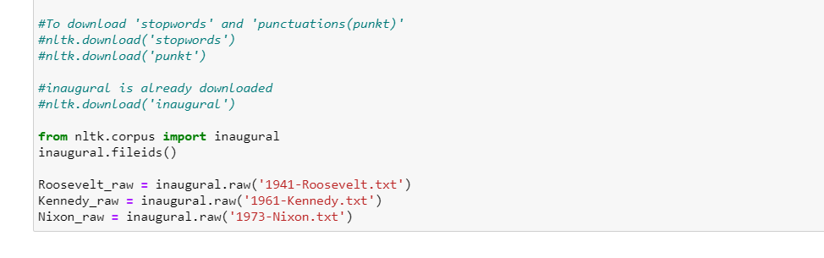
Now, let’s check length of all 3 files:
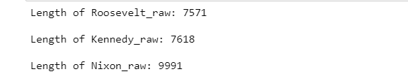

The variable 'Roosevelt_raw' contains a string with 7571 characters, Kennedy_raw contains 7618 characters, and Nixon_raw contains 9991 characters. This is the raw content of the speech, including many details we are not interested in such as whitespace, line breaks and blank lines. Notice the \r and \n in the opening line of the file, which is how Python displays the special carriage return and line feed characters. For our language processing, we want to break up the string into words and punctuation. This step is called tokenization, and it produces our familiar structure, a list of words and punctuation.

Removing unwanted characters:
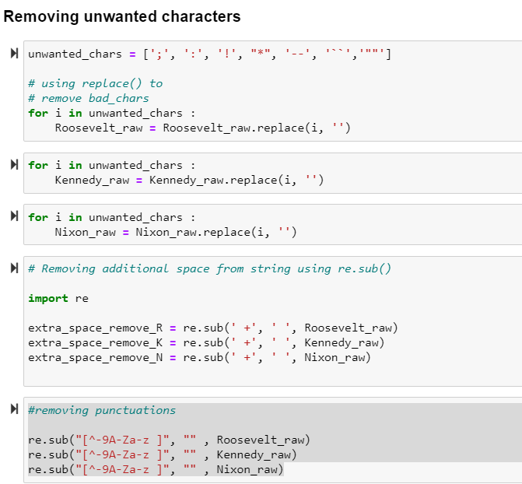

Converting all upper case words to lower case:
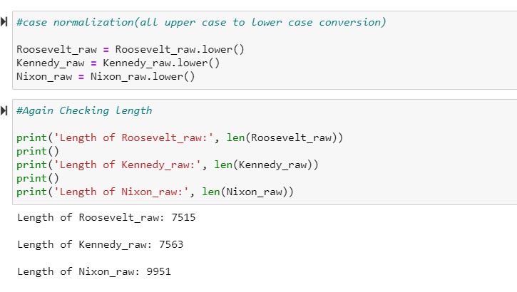
Checking the length of the token after tokenization:

length of tokens: 1492
['on', 'each', 'national', 'day', 'of', 'inauguration', 'since', '1789', ',', 'the']
-------------------------------------
length of tokens: 1512
['vice', 'president', 'johnson', ',', 'mr.', 'speaker', ',', 'mr.', 'chief', 'justice']
-------------------------------------
length of tokens: 1983
['mr.', 'vice', 'president', ',', 'mr.', 'speaker', ',', 'mr.', 'chief', 'justice']

Checking Number of sentences in all 3 speeches:
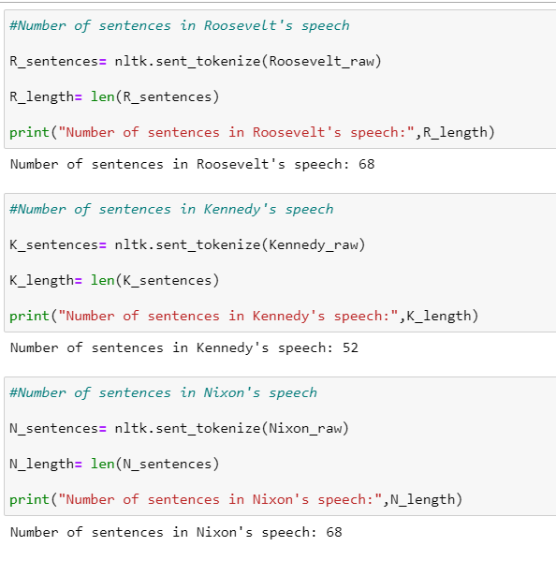

Checking texts from R_text:

['the', 'democratic', 'aspiration', 'is', 'no', 'mere', 'recent', 'phase', 'in', 'human', 'history', '.', 'it', 'is', 'human']
------------------------------

Checking texts from K_text:

['area', 'in', 'which', 'its', 'writ', 'may', 'run', '.', 'finally', ',', 'to', 'those', 'nations', 'who', 'would', 'make', 'themselves', 'our', 'adversary', ',']
------------------------------

Checking texts from N_text:

['to', 'new', 'has', 'not', 'been', 'a', 'retreat', 'from', 'our', 'responsibilities']

Checking the predefined set of stopwords:
Stopwords
['i', 'me', 'my', 'myself', 'we', 'our', 'ours', 'ourselves', 'you', "you're", "you've", "you'll", "you'd", 'your', 'yours', 'yourself', 'yourselves', 'he', 'him', 'his', 'himself', 'she', "she's", 'her', 'hers', 'herself', 'it', "it's", 'its', 'itself', 'they', 'them', 'their', 'theirs', 'themselves', 'what', 'which', 'who', 'whom', 'this', 'that', "that'll", 'these', 'those', 'am', 'is', 'are', 'was', 'were', 'be', 'been', 'being', 'have', 'has', 'had', 'having', 'do', 'does', 'did', 'doing', 'a', 'an', 'the', 'and', 'but', 'if', 'or', 'because', 'as', 'until', 'while', 'of', 'at', 'by', 'for', 'with', 'about', 'against', 'between', 'into', 'through', 'during', 'before', 'after', 'above', 'below', 'to', 'from', 'up', 'down', 'in', 'out', 'on', 'off', 'over', 'under', 'again', 'further', 'then', 'once', 'here', 'there', 'when', 'where', 'why', 'how', 'all', 'any', 'both', 'each', 'few', 'more', 'most', 'other', 'some', 'such', 'no', 'nor', 'not', 'only', 'own', 'same', 'so', 'than', 'too', 'very', 's', 't', 'can', 'will', 'just', 'don', "don't", 'should', "should've", 'now', 'd', 'll', 'm', 'o', 're', 've', 'y', 'ain', 'aren', "aren't", 'couldn', "couldn't", 'didn', "didn't", 'doesn', "doesn't", 'hadn', "hadn't", 'hasn', "hasn't", 'haven', "haven't", 'isn', "isn't", 'ma', 'mightn', "mightn't", 'mustn', "mustn't", 'needn', "needn't", 'shan', "shan't", 'shouldn', "shouldn't", 'wasn', "wasn't", 'weren', "weren't", 'won', "won't", 'wouldn', "wouldn't"]

Again checking the length of tokens:
length of tokens: 1492
['on', 'each', 'national', 'day', 'of', 'inauguration', 'since', '1789', ',', 'the']
-------------------------------------
length of tokens: 1512
['vice', 'president', 'johnson', ',', 'mr.', 'speaker', ',', 'mr.', 'chief', 'justice']
-------------------------------------
length of tokens: 1983
['mr.', 'vice', 'president', ',', 'mr.', 'speaker', ',', 'mr.', 'chief', 'justice']

Checking the top 3 Most Frequent words:
For Roosevelt speech: Nation, know and Spirit.
[('nation', 12), ('know', 10), ('spirit', 9)]

For Kennedy: let, us and world.
[('let', 16), ('us', 12), ('world', 8)]

For Nixon: us, let and America
[('us', 26), ('let', 22), ('America', 21)]

Making the word cloud for all 3 speeches:

1. For Roosevelt:

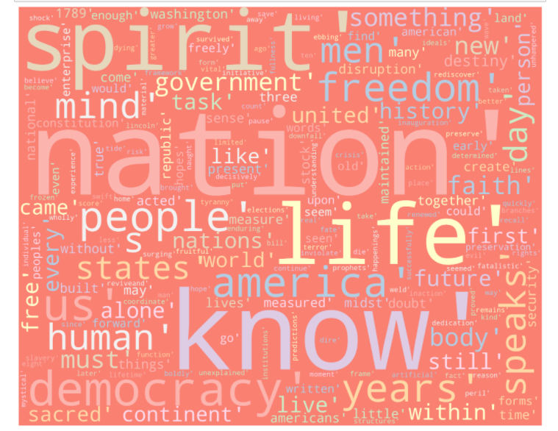

2. For Kennedy:

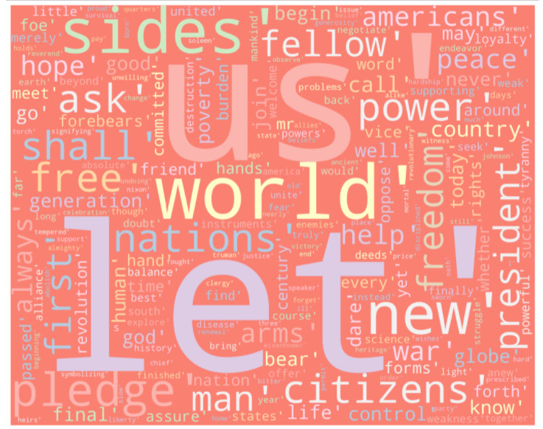

3. For Nixon:
